Vogelgezang
De Mond Cottage

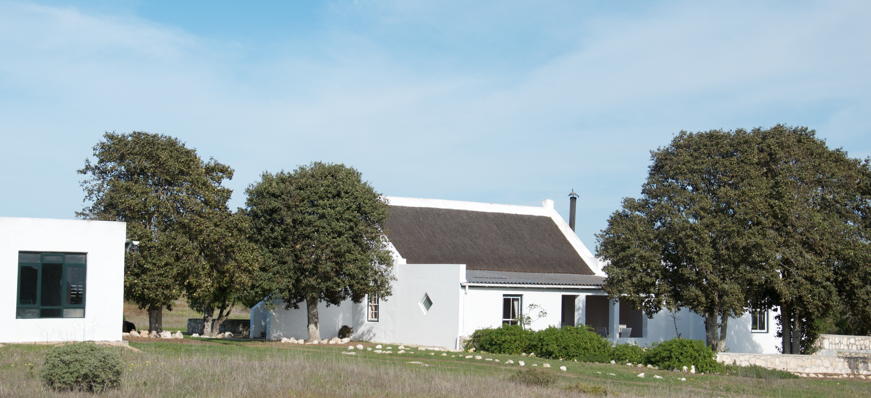

The cottage was originally built in the early 1900’s for the retiring owners at that time. The cottage lies in a patch of natural fynbos surrounded by arable lands. It is out of sight from the main homestead and the farm accommodation, providing privacy and peace! It is 2km from the gates of De Mond Nature Reserve, one of the Cape’s best kept secrets!

The mouth of the Heuningsnes River (De Mond) lies between the villages of Arniston and Struisbaai and is only 2 hrs drive from Cape Town. The estuary is pristine and uniquely “Southern Cape coast” as visitors to de Hoop Nature Reserve and the Arniston area will testify. The estuary and surf fishing is fantastic ………. Grunter, steenbras, leervis, elf, cob, springer and striped harder all occur in this estuary and along the coast.

Birding is awesome too. The Damara terns of De Mond graciously share the estuary with emigres, the Caspian terns, who have a breeding colony at the mouth. The African black oystercatcher is also an endangered species occurring at the estuary. Blue Cranes and flamingoes and pelicans are amongst the many birds to be seen in the vlei and fields on the farm. Afterall … “Vogelgezang” means “bird song”.

The bike rides and walks in the fynbos (600 hectares of it) and the beach are something to remember and the fynbos, particularly in late winter, is quite amazing.

If you just feel like chilling for the weekend, you will find the cottage quite relaxed and comfortably furnished. The views of the farmlands, sea and sunset will calm your soul.
THE THATCHED COTTAGE INCLUDES:

- Self-catering kitchen - fully equipped with gas fridge, gas stove & oven, or the choice of two outside braai’s.
- Crockery and cutlery.
- Comfortable Lounge.
- Cottage sleeps 6-10 persons
- 3 downstairs bedrooms (sleeps 6): with queen size bed and two with 2 single beds in each.
- pillows & duvet inners are provided and by request, linen can be provided at an extra cost
- upstairs loft (4 single beds – sleeps 4)
- Two bathrooms, one with shower (en suite) and one with shower and bath (shared)
- Outside shower
- Wood-burning 'donkey' for heating water
- Small covered verandah
- Outside games room with table tennis & dartboard
- A small farm “reservoir” has been converted into a plunge pool with a deck and is ideal for cooling off, just chilling or sundowners with its views of the sea & dunes.

Note: there is no electricity – the cottage is “off the grid” - paraffin lamps and candles are provided

RATES From 1 January 2022
- R2300 per night
- R2600 per night (peak season – Easter / Christmas / New Year)
- Additional fee for over 10 persons
- Midweek rates & off peak rates available upon request
- A 50% non-refundable deposit is payable on booking
- Upon receipt of deposit, booking will confirmed and balance to be paid minimum 14 days before arrival (Note: peak season - balance is due 30 days prior to arrival)

MINIMUM STAY
- 2 nights (off peak season)
- 3-4 nights (long weekends)
- 4 nights (Easter)
- 7 nights (peak season)

NO SMOKING: Smoking is NOT permitted in the Cottage. Guests need to be aware of the potential of fire hazards with cigarettes, paraffin lamps and candles.

PETS: We regret NO PETS allowed
NOTE: Gas fridges take longer to reach the desired temperature upon filling them, hence we suggest you bring along an extra cooler boxes with ice.

BANKING DETAILS:
Account Holder: Lets Go Farming (Pty) Ltd.
Bank: ABSA Bredasdorp (Branch code 334412)
Account No: 4057631941 (Current Account)

WHAT TO BRING
- Bedding (blankets, duvets, sleeping bags)
- Bed linen (pillow cases, sheets etc)
- Towels
- Personal toiletries
- WILD CARD (entrance to Nature Reserve) https://www.sanparks.org/wild_new/
- Cooler Box
- Ice
- Brikettes (wood is provided)
- Umbrella
- Hammock
- Torch
- Binoculars
- Birding books
- Fynbos books
- Games
- Mountain Bikes
- Fishing Gear
- Hiking Boots
- In winter – extra blankets and hot water bottle

ACTIVITIES:
- Birding
- Fishing (surf fishing and salt-water flyfishing)
- Walking / Hiking through fynbos (3 routes)
- Trail running
- Swimming
- Beach walks
- Cycling – off road trail ride (2 routes)
- Reading & relaxing
- Entertainment room for children with table tennis & dart board

Reservations & enquiries email: vgzgbookings@absamail.co.za or www.vogelgezang.co.za

