
Elim Home “Legacy” Project.
Elim Home are celebrating 60 years of existence. Be part of this marvellous initiative
We are running a Legacy Project whereby we ask for a minimal contribution towards the project.

We are covering a wall panel with tiles; each tile represents a donation/sponsor.
There are thee (3) different valued tiles: Small (R 60 – R 100)
Medium (above R 100 – R 1000)
Large (above R 1000).
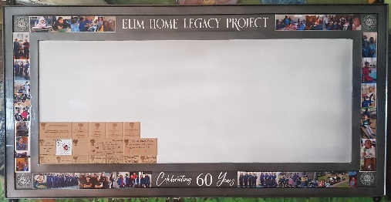
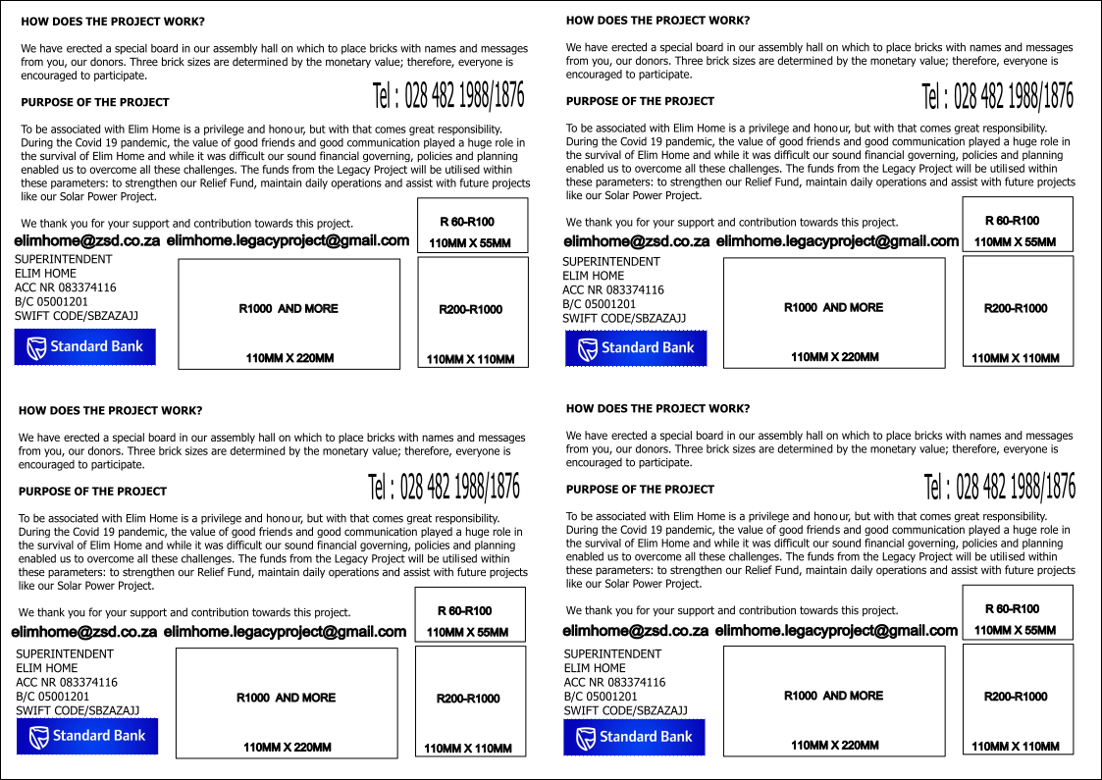

We know that we can depend on you support.


Yours truly.

Lesinda Cunningham
Director
ELIM HOME “LEGACY’’ PROJECT |  |  |  | REF.NR: | EHLP
Name: |  |  |  |  | Date:
Company/congregations |  |  |  |  | Contact nr.:
Tile size | Value | Pick one | Donation value |  | BANKING DETAILS
Small |  |  |  |  | Elim Home, Standard Bank
Medium |  |  |  |  | Account number: 083374116
Large |  |  |  |  | Branch code: 05001201

