GANSBAAI
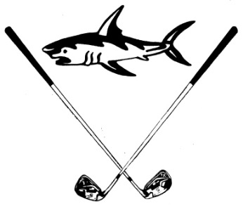
GOLF CLUB – GHOLFKLUB
 1123, GANSBAAI 7220  028 384 1441  gbgholf@gmail.com

Newsletter September/October ║Nuusbrief September/Oktober

The Southernmost Golf course in Africa
Die mees Suidelike Gholfbaan in Afrika

“A natural grass course, situated in Cape Fynbos with a touch of links in summer”
“’n Natuurlike grasbaan, geleë in Kaapse Fynbos met ‘n sweem links in die somer”
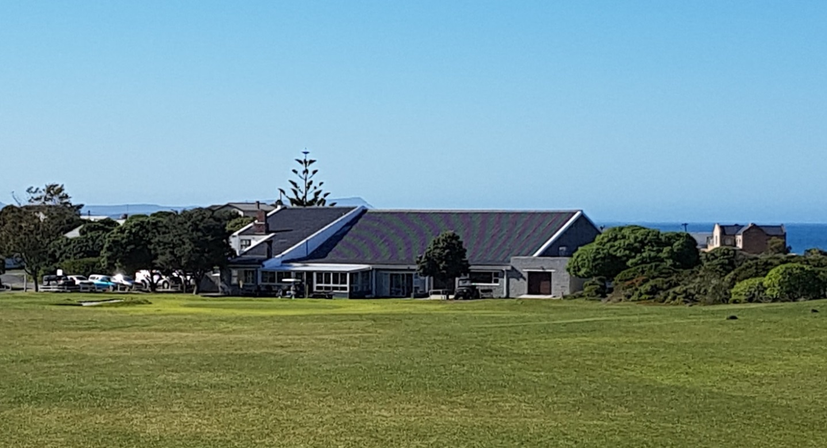
YOUR NEW CLUB COMMITTEE / U NUWE KLUBKOMITEE
(final revised edition / finale hersiene weergawe)

PORTFOLIOS: / PORTEFEULJES:
Competitions and Sponsors: / Kompetisies en Borge: Pieter Loubser & Johan Pfister
Buildings: / Geboue: Hennie Kriel & Johan Pieterse
Newsletter and Media: / Nuusbriewe en Media: Fanus Walters & Johan Coetzee
Policy and Personnel Matters: / Beleid en Personeelsake: Koos Myburgh
Handicaps: / Voorgee’s: Johan Coetzee & Pieter Loubser
Course: / Baan: Dicky de Kock
Finance, Stock and Insurance: / Finansies, Voorraad en Versekering: Johan Coetzee & Clive Bailey
NEW HANDICAP SYSTEM FROM 1 OCTOBER 2019
(last repeat / laaste plasing)

“Nine-hole scores”

Nine-hole competitions and nine-hole rounds are becoming increasingly popular globally. This is mainly due to the time it takes to play 18 holes, but also due to personal preferences. As such, 9-hole scores are an important part of the handicap calculation.
We are sure you have noticed that, at many courses, one nine plays harder than the other nine. To ensure that the Handicap Indexes are as close as possible to the golfer's ability, we will be introducing nine-hole Course Handicaps and a revised nine-hole handicap score calculation on the 1st October 2019. This will be in line with that required under the World Handicap System Rules coming in January 2020.

The basics: what you need to do when playing nine holes: From the 1st October, simply look up your 9-hole Course Handicap, which is what you will play off for the nine you elect to play. When entering your score, use your 9-hole Course Handicap to adjust your maximum score on any hole that you blow out on and enter this Adjusted Gross Score for nine holes – the system will do the rest.

Detailed explanation of the change to 9-hole score calculations on 1 October 2019

The current 9-hole system: Our current 9-hole handicap calculation takes the nine-hole Adjusted Gross Score you enter and the Slope of the tee you played off, and then adds par for the second nine, plus half your handicap strokes, resulting in an 18-hole Adjusted Gross score.
The actual calculation is as follows: 9-Hole Score Differential = (Adjusted Gross Score for 9 holes x 113/Slope Rating + second nine par + 0.5 x Course Handicap) - Course Rating.

Future World Handicap System: When all the courses in South Africa were rated with the USGA Course Rating System, a Course and Slope Rating for each nine, as well as for the overall course, was determined and is currently published on the HNA website. As of October 01, we will now use these 9-hole ratings to determine your nine-hole Course Handicap.
Example: On some courses, although par is the same on each nine, the Course Rating and Slope can be very different. For example, if we look at Rand Park Firethorn, the par-72 course where the 2019 SA Open was played, we can see that the White course for Men has a CR/SR of 36.0/132 for the front 9 and 37.7/139 for the back nine, with an overall rating of 73.8/136. So the 18-hole Course Rating is 73.8/136, but it is different by 1.7 shots on each nine and the Slope rating varies by 7.
Therefore, if a golfer at Rand Park always plays the harder nine, with a CR of 37.7/139, under our existing system of just using the 18-hole Course Rating, he/she would have a Handicap Index higher than it should be.”
Source: Copied and pasted from the Handicaps African Newsletter July Handicap news
CLUB NEWS / KLUBNUUS
- We are glad that our Club Captain, Bev Swart, is back home and feeling well after he had heart valve surgery.
Ons is bly dat ons Klubkaptein, Bev Swart, terug is nadat hy suksesvolle hartklep operasies ondergaan het.

- Competition results/Kompetisie-uitslae, Sat/Sa 31 Aug, 2-ball American Scramble/ Beurtspel – Sponsored by/Geborg deur Flying Fish (thanks to/te danke aan Pieter Loubser (organiser/organiseerder), Melvin Tobias (donated meat prizes/donateur vleispryse) and/en Christo Spanellis (donated beer prizes/donateur bierpryse):

Winners:/Wenners: Daniël & Francois vd Merwe (photo/foto)

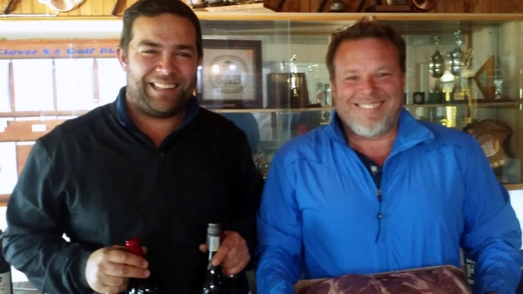

- Competition results/Kompetisie-uitslae, Sat/Sa 7 Sep, Monthly Medal/Houespel:

Winner:/Wenner: Johan Coetzee 69 net (photo/foto)



- Competition results/Kompetisie-uitslae, Sat/Sa 14 Sep, 4BBB Stableford – Green fees for prize money/Speelfooie vir prysgeld:

Winners:/Wenners: Johan Coetzee & Wally van Coller (photo/foto)

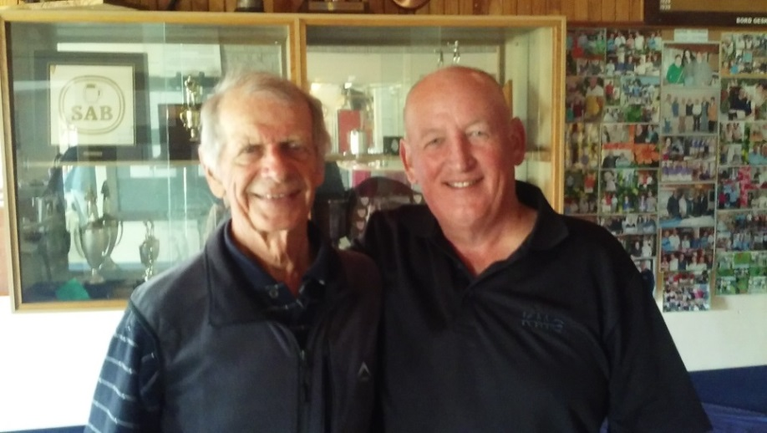

- Competition results/Kompetisie-uitslae, Thu/Do 19 Sep, SAGES 4BBB Stableford Overberg vs Langeberg, played at / gespeel op Bredasdorp :

Winners:/Wenners: Charlie Bent & Trevor Archer (Overberg) 44 pts/pte.
Second:/Tweede: Gert Albertyn & Pieter le Riche (Langeberg) 42 pts/pte.
Third:/Derde: Deon Steenkamp & Piet de Bod (Langeberg) 42 pts/pte.

Overberg (38 pts/pte, ave/gem) won/wen Langeberg (36,8 pts/pte, ave/gem).

- Competition results/Kompetisie-uitslae, Sat/Sa 21 Sep:

No play due to bad weather. / Geen spel nie a.g.v. swak weerstoestande.

- Position of 2019’s Knockout Competition at this stage:/Status van 2019 se Uitklopkompetisie op hierdie stadium:

Singles/Enkels - Final games to be played:/Laaste wedstryde wat wag:
The winner between Daan Victor & Bertie Laubscher vs Hugo Groenewald.
Foursomes/Vierbal – The winners are:/Wenners is: Clive Bailey & Daan Victor.
Pairs/Pare – The winning pair between Hugo Burger & Hennie Kriel vs Leon Lombaard & Etienne Engelbrecht must play out against the winning pair between Dawie Viljoen & Piet du Toit vs Solly Wessels & Wally van Coller.
Mixed pairs/Gemengde pare – Barry Fourie & Marie Fourie must play out against Pieter Loubser & René Myburgh to determine the winning pair.
2 Ball American Scramble/Beurtspel – The winning pair between Daan Victor & Clive Bailey vs Dawie Viljoen & Piet du Toit must play out against Andrew Dalgliesh & Johan Coetzee.

- SUCCESSFUL STEAK-AND-CHIPS EVENING!!! /
SUKSESVOLLE BIEFSTUK-EN-SKYFIES AAND!!!
What a great success. Our golfing community and friends supported this social event on the 30-th of August to a bumper attendance and more than 90 steaks sold!
Wat ‘n groot sukses. Ons gholffamilie en -vriende het hierdie sosiale geleentheid op 30 Augustus in groot getalle bygewoon en meer as 90 biefstukke is verkoop!
Some comments and thank you messages: / Sommige se kommentaar en bedankings:
- Gertrude Karg – “Steakbraai was heerlik dankie julle … waardeer.”

- Colleen Knox – “Ons Social Members bring baie geld in die klub in. Ons is ‘n “jolly” groep.”

- Manie Serrao – “I would just like to thank Bev and staff for the fantastic energy he brought to the Golf club on Friday evening. There was a buzz of happiness and fun that hasn’t been there in a very long time. Francis the flowers on the tables and the sale thereof towards the end of the evening was such a good idea for funds towards making the Golf club more lekker … we look forward to many more lekker evenings socially. And the brandydraw … baie dankie Sakkie.”

- Erica Lamprecht – “I agree!”

- Francis Swart – “Baie dankie vir almal se donasies en die wat blomme gekoop het. Ons het R1 480-50 ingesamel wat aangewend sal word om die dames se kleedkamers bietjie mooi te maak. Ons sal egter nog planne moet maak vir meer geld …”

- Julia Barlow - “We need to find a sponsor. Thank you (Francis) for your fundraising initiative.”
A word of thanks to: / Baie dankie aan:
Braaiers: Hennie Kriel; Johan Kellerman; Steve Muller.
Chips:/Skyfies: Dickie de Kock
Next Steak-evening: 27 Sep at 18:30 / Volgende Biefstuk-aand: 27 Sep om 18:30.
UPCOMING COMPETITIONS / KOMENDE KOMPETISIES
Participate and enjoy your member benefits !!!
Neem deel en geniet die voordele van jou lidmaatskap !!!
OCTOBER / OKTOBER 2019

DATE / DATUM | DAY / DAG | COMPETITION / KOMPETISIE | INFORMATION: TIME / SPONSORS  INFORMASIE: TYE / BORGE
2 | Wed/Wo | SINGLE / ENKEL STABLEFORD (SLOEGTERS)
4 | Fri/Vr | 9 HOLE / PUTJIE SINGLE / ENKEL STABLEFORD
5 | Sat | HOUESPEL
6 | Sun/So | SINGLE / ENKEL STABLEFORD | BEGIN 10:00
9 | Wed/Wo | SINGLE / ENKEL STABLEFORD (SLOEGTERS)
11 | Fri/Vr | 9 HOLE/PUTJIE SINGLE / ENKEL STABLEFORD | OK FOODS PLUS
12 | Sat | 4BBB STABLEFORD | MEMBER DAY / LEDEDAG
13 | Sun/So | SINGLE / ENKEL STABLEFORD | BEGIN 10:00
16 | Wed/Wo | SINGLE / ENKEL STABLEFORD (SLOEGTERS)
18 | Fri/Vr | 9 HOLE / PUTJIE SINGLE / ENKEL STABLEFORD
19 | Sat | SINGLE / ENKEL STABLEFORD | INTER CLUB / KLUB THEEWATERSKLOOF
20 | Sun/So | SINGLE / ENKEL STABLEFORD | BEGIN 10:00
23 | Wed/Wo | SINGLE / ENKEL STABLEFORD (SLOEGTERS)
25 | Fri/Vr | 9 HOLE / PUTJIE SINGLE / ENKEL STABLEFORD | STEAK BRAAI
26 | Sat | SINGLE / ENKEL STABLEFORD | GB BEESKRAAL OPEN / OPE (ZONART)
27 | Sun/So | SINGLE / ENKEL STABLEFORD | BEGIN 10:00
30 | Wed/Wo | SINGLE / ENKEL STABLEFORD (SLOEGTERS)

OCTOBER BIRTHDAYS / OKTOBER VERJAARSDAE
Happy Birthday dear member !!! / Veels geluk geagte lid !!!

On 4 Oct, Johan and Lucille Coetzee are happily married for 50 years. Congrats!
Johan en Lucille Coetzee is op 4 Okt, 50 jaar gelukkig getroud. Hartlik geluk!
GOLF GAME TIPS: / GHOLF WENKE:
Park your ego. You know the feeling - You smack a big drive off the tee box only to watch it land deep in the rough. Not exactly what you had in mind, but hey, it’s still in play and it wasn’t THAT bad of a shot.
First thing, that little voice inside your head tells you: “Hey the lie won’t be that bad up there…you can still get it on the green in regulation!”
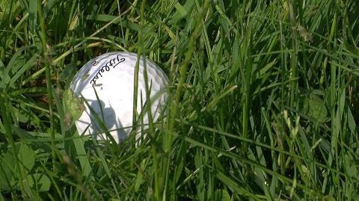
Even when you walk up to your ball and find it settled down in the rough, that little voice might still be saying something like: “Well…at least you can see the top of the ball…and if you can see it why not try to launch it up on the green with that trusty 5 iron of yours...right???" WRONG!
This is the exact moment when most golfers take one bad shot and turn it into a confidence crushing blow-up hole. You’re better than that little voice inside your head, and you can play SMART from the rough using today’s simple tips…
Choose a high lofted club. When your ball is lodged in the rough a wedge or a short iron (8 or 9) is going to help you pop it up and out. Clubs with low lofts like long irons, fairway woods, or even hybrids can get caught up in the rough and cause you to duff your ball completely, or worse, send it rocketing off into the lumber yard.
Get it back in play. It’s hard enough to hit a long approach shot onto the green from the fairway, and when you add some thick grass to the mix, things only get worse. Instead of trying to be a hero and aiming for the pin, pick a target in the fairway that will position you well for your next shot. Think of it like a game of chess - you’re setting yourself up for your next move.
Hit down on the ball. Once you choose your club and your target all that’s left to do is blast your ball out of the rough, but you don’t need to swing like a caveman. To pop the ball up, hit down on it, and be sure to finish your swing with a full weight shift to your front foot.
While it might be hard to swallow your ego and punch out into the fairway in these situations, it's going to be well worth it when you are counting up your strokes (and your winnings) at the end of the round!
Source: support@golfgame.tips
PLEASE NOTE!
MEMBERSHIP/SUBSCRIPTION FEES:
PLEASE DIRECT ALL QUERIES REGARDING MEMBERSHIP
TO JOHAN COETZEE, TREASURER gbgholf@gmail.com
THANK YOU!

This Newsletter was compiled by Fanus Walters.
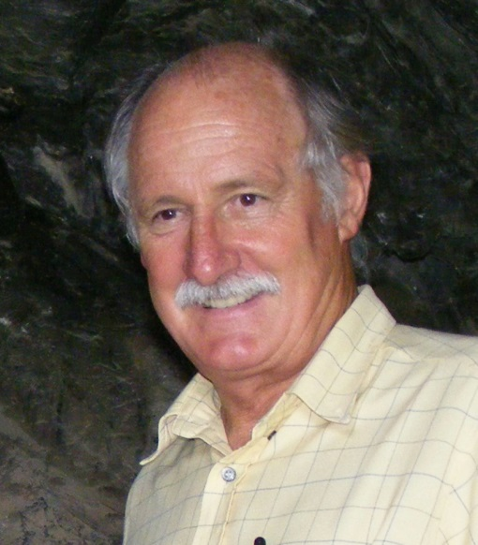
You are welcome to contact the Club at:
Hierdie Nuusbrief is deur Fanus Walters opgestel.
U is welkom om die Klub te kontak, by:

Golf email: gbgholf@gmail.com
Web address: https://xplorio.com/gansbaai golf
Facebook: Gansbaai Gholfklub/Golf Club
--oo0oo--

