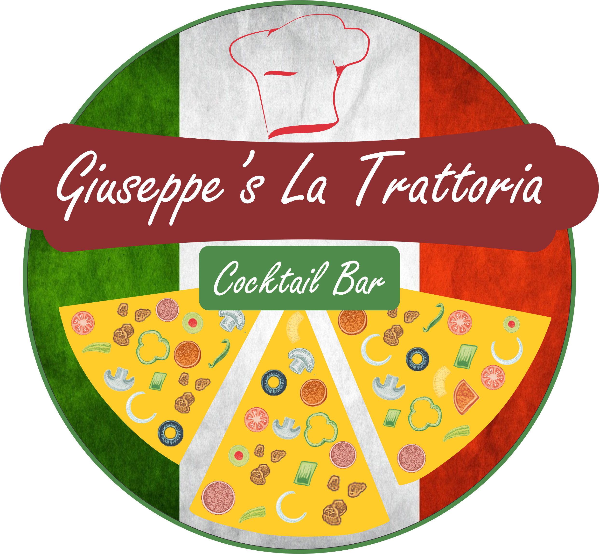

Welcome to Giuseppe’s Trattoria

A Trattoria is an Italian-style eating establishment, less formal than a ristorante, but more formal than an Osteria. There are generally no printed menus, the service is casual, wine is sold by the decanter rather than the bottle, prices are low, and the emphasis is on a steady clientele rather than on haute cuisine. The food is modest but plentiful (mostly following regional and local recipes) and in some instances is even served family-style (i.e. at common tables).

Tel: 071 657 9732

Tel: 082 483 8408

Your Hosts:

Gino “The Don”
&
Derek Capo
&
Benita Capo Bella

Buon Appetito!

Grazie Mille
KIDDIES / MENU BAMBINI

Pizza Cheezy Hammy (23 cm) R 90
Viennas & Chips and Dip Sauce R 60
Chicken Strips & Chips and Dip Sauce R 65
Fish Fingers & Chips and Dip Sauce R 65
Bambini Snack Basket – Viennas, Fish Fingers, Chips, Sauce R 85

TOASTED SARMIES

Choice of white / brown bread
or Tramazzini

Sarmies Served with side portion of chips

Cheddar Cheese R 45
Cheese and Tomato R 50
Braai Broodjie (Tomato, Cheese, Onion and Sweet Chilli Sauce) R 60
Banks Toastie (Egg & Cheese & Tomato) R 55
Ham, Cheese and Tomato R 55
Chicken Mayo R 65
Chicken Mayo, Feta and Honey mustard R 70
Tuna Mayo R 68
Bacon & Egg R 60
Bacon, Egg & Cheese R 65
Bacon, Feta and Avo R 70
Bacon & Cheese R 60
Bacon, Banana and Cheese R 65
Chicken Mayo, Bacon and Cheese R 75
Vegetarian: Cheese, Avo, Tomato and Gherkins R 60
Bolognaise Mince and Cheese R 75
Add Extra Small Chips R 35

SNACK BASKETS
Uno Basket
Crumbed Mushrooms, Spare Ribs and Chips R 85
Duo Basket
Chicken Strips, Crumbed Mushrooms and Chips R 80
Tre Basket
Chicken Strips, Spare Ribs, Crumbed Mushrooms and Chips R 95
Quattro Basket
Spare Ribs, Chicken Strips, Russian, Onion Rings and Chips R 100
Kelp Garlic Roll & Onion Rings R 65
Russian & Chips R 85
Half Portion Russian & Chips R 45

Fully Loaded Chips
Chips, Bacon Pieces Smothered with Cheddar Cheese Sauce R 85

Chips Medium Portion R 40

Chips Large Portion R 55

Onion Rings R 40

BURGERS
(Served with Side Portion of Chips) and on a Tramazzini
Lemo Burger R 95
100% Pure Beef patty 200g, Tomato, Lettuce, Onion, Gherkin, and our Secret sauce.
Maureen Burger R 105
100% Pure Beef patty 200g, Bacon, Avo, Tomato, Lettuce, Onion, Gherkin, and our Secret sauce.
Taya Burger R 100
100% Pure Beef patty 200g, Pineapple, Tomato, Lettuce, Onion, Gherkin, and our Secret sauce.
Ansie Burger ( Cheese Burger) R 95
100% Pure Beef patty 200g, Tomato, Lettuce, Onion, Gherkin, and Cheddar Cheese.
Mario Burger R 95
Crumbed Chicken breast fillet, Tomato, lettuce, onion, Piccalilli.
Lereen Burger R 95
Crumbed Chicken breast fillet, Tomato, lettuce, onion with Sweet Chilly Sause.
Timo Burger R 100
Crumbed Chicken breast fillet, Bacon, Avo, Tomato, lettuce, onion.
Add Chips R 35

PASTA’S
Alfredo R 130
Pasta with Ham and Mushrooms Creamy sauce
Bolognese R 135
Pasta with Bolognese sauce
Bucaniera – (Pirate ) R 140
Pasta with Seafood mix, Napolitana sauce, Wine and Fresh Garlic
Puttanesca – (Lady of the Night ) R 135
Pasta with Napolitana sauce, Olives, Anchovies, Tomatoes, Garlic
Autunno R 135
Pasta with Cream sauce, Chicken, Mushrooms, Green Peppers and Peppadews

SALADS
Greek Salads R 85
Basic Salad with Feta, Olives and Onions
Chicken Salad R 95
Basic Salad with Grill Chicken Pieces and Onions
Side Green Salad R 45

MEALS

Starters
Snails R 85
Served in a Creamy Garlic sauce with melted Cheese
Crumbed Mushrooms R 65
Served with Lemon and Secret sauce
Jalapino Poppers R 60
Poppers with Sweet & Sour Sauce and Mayo
Chicken Livers Hot or Not R 55

MAIN COURSE

Pork Spare Ribs R 225
Served with Chips / Salad Or Half - Half
Bonsai Ribs R 130
Ladies portion with Chips / Salad Or Half - Half
Chicken Schnitzel R 135
Served with Chips / Salad Or Half – Half and Sauce of your choice
Chicken Strips R 125
Crumbed Chicken strips with Chips / Salad Or Half - Half and Sauce of your choice
Extra Sauces R 40
Mushroom / Pepper / Garlic or Cheddar-melt / Cheese sauce

All our meals are freshly made to order. Our Pizza bases are freshly rolled to order. It may take a little longer to prepare. So why don’t sit relax and enjoy some of our wide range of drinks and Cocktails.

PIZZAS

Pizza Piccola Grande
(23cm) (30cm)
Brekvis Pizza R 110 R 145
Pizza base topped with Scramble Eggs, Bacon, Mushrooms
and Fresh Tomato
Focaccia R65 R 80
Garlic & Herbs with no Mozzarella
Cheezy Focaccia R80 R 120
Garlic & Herbs with Mozzarella
Margherita ( V ) R 95 R 120
Mozzarella, Tomato base and Oregano
Regina R 125 R 155 Ham and Mushrooms
Hawaiian R 125 R 155 Ham and Pineapple
Mediterranean V R 135 R 160
Olives, Peppadew, Tomatoes and Feta
3 Cheeses V R 125 R 160 Mozzarella, Feta, Cheddar and Oregano
Romina R 130 R 165
Salami, Ham, Mushrooms and Olives
Four Seasons R 160 R 195 Salami, Mushrooms, Olives, Green peppers, Pineapples,
Onions and Asparagus
Californian R 135 R 175 Bacon, Feta and Avocado
Italiano R 150 R 185
Ham, Salami, Bacon, Mushrooms and Olives
Mexicano Hot!!! ^{NOT FOR THE FAINT-HEARTED} R 155 R 195
Mince, Onions, Chillies and Peri-peri sauce
Tikka Chicken Spicy hot! R 140 R 175 Chicken, Mushrooms, Peppadews, Onions
and tikka sauce
Al Capone Mild R 150 R 165
Chicken, Onions, Tomatoes, Mushrooms
and Sweet Chilli sauce
Tropicana R 140 R 170
Bacon, Salami, Garlic and Bananas
Ronaldo R 145 R 170
Chicken, Mayo, Green peppers and Onions
Caribbean R 145 R 170
Bacon, Ham, Peppadews and Pineapples

Fabio R 145 R 170
Chicken, Mushrooms, Green peppers, Feta and
Sweet and Sour sauce
Malta R 130 R 170
Bacon, Blue Cheese and Green Fig Preserve
Napoli R 130 R 165
Olives, Capers and Anchovies
Mamarazzi R 145 R 175
Deboned Ribs, Peppadews, Feta and Garlic
Quattro Carni R 175 R 200
Bacon, Deboned Ribs, Ham and Salami
Gino R 160 R 195
Bolognaise Mince, Tomatoes and Feta
Seafood R 150 R 185
Mussels, Shrimps, Calamari, Tuna, Crabsticks and
Seafood sauce
Biltong R 150 R 180
Biltong, Peppadew, Feta and Avo
Jollisimo R 145 R 175
Chicken, Bacon, Sweet and Sour and Avo
Sliema R 145 R 175
Salami, Bacon, Mozzarella & Cheddar and Peppadew
Godfather R 130 R 155
Chicken, Spinach, Feta and Creamy Mayo

Create your own pizza or spice up your pizza Grande (30cm)
Margherita Base R 120
Ham, Salami, Bacon, Chicken, Ribs, Biltong
Mince, Seafood, Anchovies, Feta,
Mozzarella, and Avo,
Olives, Peppadews, Capers,
Cheddar, Asparagus R 25 each
Tomatoes, Pineapples, Green Peppers, Onions R 15 each
Spinach

DESSERTS / IL DOLCE

Malva Dessert R 75
Chocolate Velvet Slice R 65
Death By Chocolate R 80
Ice Cream & Chocolate sauce R 55

BEVERAGES

Ceylon / Rooibos Tea / Coffee R 23
Hot Chocolate R 40
Milkshakes R 45
Kiddies shake R 35
Coke Float R 45
(Banana, Bubblegum, Caramel, Chocolate, Lime, Strawberry, Vanilla)

Useless information
The town of Gansbaai originates from 1881 when an adventurist, Johannes Cornelis Wessels, walked here from Stanford and discovered the fishing possibilities and freshwater fountain near the old harbour. Other families followed suit and named the place Gansgat after a colony of Egyptian geese that congregated at the fountain. It was later altered to the more respectable Gansbaai.

The Don Gino wants to thank you for Your Support,

If you wish to complain, that department is on annual leave and will be in fully operational on 31st Feb. Hope you have enjoyed the homely, friendly and warm atmosphere. We are looking forward to your next visit.

The popular pizza Margherita owes its name to Italy's Queen Margherita who in 1889 visited the Pizzeria Brandi in Naples. The Pizzaiolo (pizza maker) on duty that day, Rafaele Esposito created a pizza for the Queen that contained the three colours of the new Italian flag. The red of tomato, white of the mozzarella and fresh green basil, was a hit with the Queen and the rest of the world. Neapolitan style pizza had now spread throughout Italy and each region started designing their own versions based on the Italian culinary rule of fresh, local ingredients.

SALUTI

