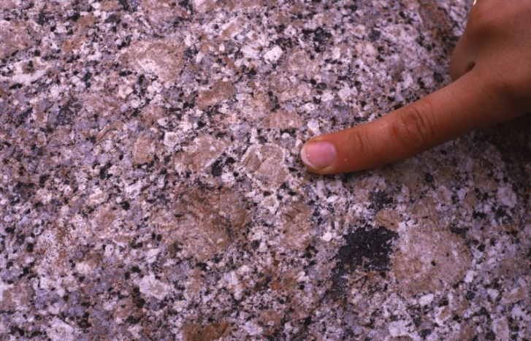
HEMEL EN AARDE WINE VALLEY
The Story of the Rocks and Soils that make our wine.
-----------------------
CONTACT:
Hermanus: John Blaine - 083 702 2158; jblaine44@outlook.com
John Bristow - 082 571 3004; jwbdia@gmail.com
Admin: Hennie Greeff – 082 569 5314; hennie.greeff@gmail.com

OVERBERG GEOSCIENTISTS GROUP (OGG)

The OGG has established two Earth Age Displays with Rock Gardens at Betty’s Bay (Harold Porter Botanical Garden) and Gansbaai (African Penguin Sanctuary). Designed to educate lay-persons and learners about the make up and origins of the Earth and the rocks around us.

Betty’s Bay: Earth Age Display and Rock Garden - Harold Porter Botanical Garden

- The OGG also holds regular online and ad hoc meetings, and field excursions for members and interested parties, with nominal membership fees of R250 per annum.

- Donations and sponsorship from interested parties are important to fund these larger projects.

The OGG is registered as a Non-Profit Organisation (Reg. No. 275-138 NPO).

Banking details: Bank: Standard Bank
Account Name: Overberg Geoscientists Group NPC
Account number: 10168933800
Type: Current Account
Branch code: 051001 Swift Address: SBZA ZA

Please advise your name and address with payment.

Granite boulder: Large blocky pink crystals are feldspar
(K, Na, Ca) AlSi₃O_{8.} Smaller glassy, grey crystals are
quartz (SiO₂ ) and dark flecks are biotite mica
(K(Mg, Fe)₃AlSi₃O₁₀(FOH)₂ ). Rusty patches seen on
outcrops are weathered mica.

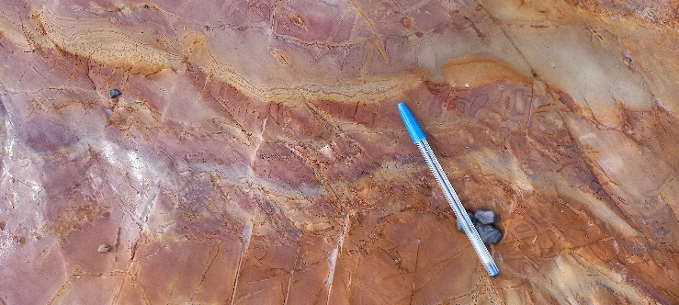.
Bokkeveld mudstone (“shale”),
Bright varicoloured outcrop in road cutting (R320)near Creation Wines turn-off.
Comprises very fine grained clay minerals and quartz, with relatively large pore spaces to hold moisture (<0.0005mm, below).

OGG Brochure #5
HEMEL EN AARDE WINE VALLEY
The Story of the Rocks and Soils that make our wine.

Highlights:

- Rotary Drive: Picture the geological setting
- How old are these rocks and how did they form?
The different parts of the Hemel en Aarde Wine Valley.

- ROCK TYPES:
- Cape Granite (Hermanus Pluton):
- Age: ~550 Million years (Ma)
- Soil: Clay-rich from decomposed feldspar
- Gritty from constituent quartz grains.
- Excellent moisture absorption and nutrition

- Table Mountain Group (Sandstone v. minor shale):
- Age: ~500 –400 Ma
- Soil: Very sandy, predominantly quartz grains
- Poor water retention and very low nutrition

- Bokkeveld Group (Shale, lesser sandstone)
  - Age: ~400 – 385 Ma,
- Soil: Clay-rich from decomposed clay minerals
- Excellent moisture absorption and nutrition.

- STRUCTURE:
  - Confined by block faults:
  - Formed during folding and compression of Cape Fold Belt-300 -350Ma.
  - Continental Drift and the separation of Gondwanaland ~140 – 90 Ma.
  - Extensive and deep weathering during the last ~65 Ma, formed ferricrete (“Koffieklip”).

Sandstone
Shale
Granite
Faults
Sandstone
Sandstone
Hamilton Russel Vineyards:
Clay soil profile
On Bokkeveld shale bedrock.
Top: Degraded ferricrete
(koffieklip) gravelly humic soil.
Middle: Leached clay-rich zone
Bottom: Weathered bedrock
and shale fragments.
Clay minerals from breakdown of existing clay minerals in shale.

30cm
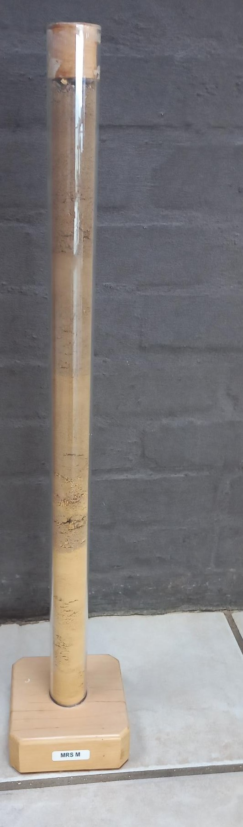
Newton Johnson Family Vineyard:
Sandy-clay soil profile
On granite bedrock.

Top: Sandy humic soil
Middle: Ferruginous, sandy clay
Bottom: Deeply weathered
gritty clay derived from granite bedrock.
Clay derived from weathering of feldspar
In the granite.
30cm
Babylonstoring 1167m
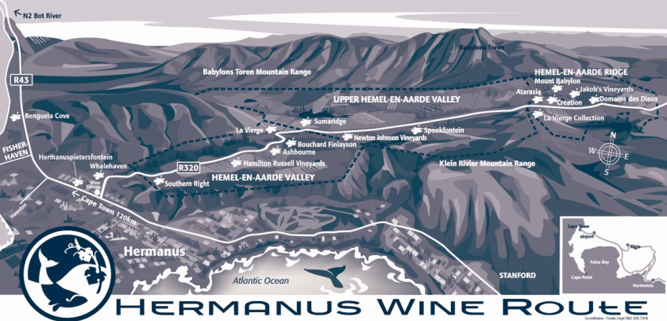

Sandstones

