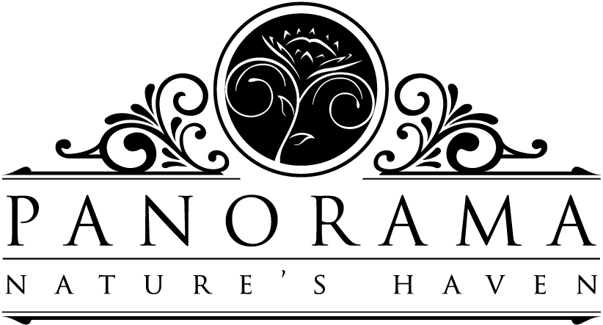
Panorama Wedding Venue 2017 Menu:
Please note that our menu is merely a guideline to guests and we will gladly quote any catering requests 3 months or closer to function date. Feel free to tell us your ideas and preferences!
Pre-drinks
Homemade lemonade – a refreshing sweet-and-sour, no-fizz drink made from freshly squeezed lemons and sugar syrup. Served with mint (Non-alcoholic) R10
Homemade ginger beer – traditional fizzy lemonade with raisins, the way grandma made it! (Non-alcoholic – well, kind of! ) R10
Berry Blaze – a delicious blend of mixed berry juice and ginger ale (Non-alcoholic) R12
Rosé punch – a refreshing blend of rosé wine and Schweppes lemonade with fresh strawberries or maraschino cherries (Alcoholic) R15
Berry Blaze– a blend of mixed berry juice and ginger ale with a splash of vodka (Alcoholic) R15
*All pre-drinks are served in our glass bottles (250ml each) with black straws (should you require a special straw, please supply).
Pre-snacks
Roosterkoek
Fresh roosterkoek (2-3 per person) made on an open fire, served hot of the coals with grated cheddar cheese, 1 homemade jam, golden syrup and butter R40/head
– add green fig preserve and soft white cheese (brie/camembert) R50/person
Bread table galore
Roosterkoek, fresh farm bread, grated cheddar cheese, camembert and brie, chicken liver pate, mixed nuts, seasonal fruit, 1 homemade jam, green fig preserve, butter R75/head

Canapés
Honey glazed oven baked bacon wrapped mushrooms
Cucumber slice topped with smooth cottage cheese, smoked salmon or garlic fried prawns and black pepper
Crispy baguette topped with chicken liver pate, apple compote and fresh thyme
Shoestring French fries, served in newspaper cones with homemade mustard sauce or tomato sauce
Biltong, blue cheese and broccoli mini quiches with baby spinach
R75/ person (1 of each item per person )

Starters
(V) Thai butternut, coconut and chilli soup with fresh coriander and crispy breadstick or roosterkoek R40 (served hot)
Chicken liver parfait served with apple compote and fresh farm bread R40 (served cold)
Bobotie square with chutney and fresh rocket R45 (served warm or cold)
Baked battered hake fillets with tartar sauce and fresh side salad R45
(V) Homemade pasta linguine topped with creamy carbonara sauce, roasted mushrooms, parmesan shavings, thinly sliced biltong and fresh parsley R65
Smoked salmon roulade with spinach and cottage cheese R70

Main Meal
Choose your meat:
Leg of lamb, topped with rich brown gravy
Millionaire’s leg of lamb – tender sliced leg, layered with mushrooms, ham and cheddar cheese and topped with basic béchamel sauce
Chicken fillet, stuffed with feta & spinach or bacon & thyme, baked to perfection and topped with a creamy mushroom or cheese sauce
Crumbed or grilled chicken portions, oven baked to crispy
Chicken pie – the traditional way! Rich, flavourful meat with flaky pastry
Pork chops, baked in a rich chutney and sage sauce
Gammon with pineapple and cherries, served with a sticky sauce
Choose 4 dishes from below to accompany your meat:
Crispy fried potatoes (braaiaartappels)
Baby potatoes in a parsley and garlic butter
Creamy potato bake with bacon, onion and mushrooms
Savoury rice, basmati rice or brown rice
Sweet potatoes with cinnamon
Pumpkin bake (pampoentert)
Creamed spinach
Roast vegetables
Broccoli & cauliflower, topped with béchamel sauce and grated cheddar cheese
Greek salad
Caeser salad
Our famous farm wheat salad
Prices:
R180/head (one meat and 4 accompanied dishes)
R50/extra meat /person
R20/extra side dish/person

Main meals are served buffet style, or served at the tables.
Other options:
Option 1:
Chicken potjie (with carrot, potatoes, baby marrows and mushrooms)
Savoury rice or basmati rice
Greek salad with dressing or Caeser salad
R150/ person - Add farm bread, jam, cheese and butter for R25/person.

Option 2
400g lamb shanks, cooked to perfection in a rich Guinness sauce, served on a bed of creamy mustard potato mash and topped off with a side of oven roasted vegetables, steaming gravy and fresh rosemary
R200/person – This meal is served at the tables

Dessert:
Malva pudding, served with vanilla ice cream or custard R35
Peppermint crisp tart served with cream and fresh mint R40
Desserts are served at the tables

Due to popular demand, we also do sweet tables:
Fudge, chocolate brownies, coconut ice, meringues with pistachio nuts, basic cupcakes, mini milk tarts, mini lemon meringue tartlets, lamingtons, mini peppermint crisp tartlets, mini tipsy tartlets with fresh cream.
Choose 4 items per person: R45/head
Choose 5 items per person: R47/head
Choose 6 items per person: R50/head
Special meals:
Kids – We do cater for children. Please choose between the following:
Main meal – 0-2 years – free
3-8 years – half price
8 and up – full price
3 Fish fingers and chips – R40 (served at the tables)
Beef burger with chips – R60 (served at the tables)
Vegetarians – Linguine pasta topped with roasted vegetables, feta, fresh baby spinach and white wine sauce – R140 (served at the tables)

Please note the following regarding our menu
Filter coffee and tea (rooibos & Ceylon) are R300 extra.
Our kitchen is not halaal, thus we do NOT cater for halaal guests unless it is only excluding pork/liquor in our meals.
We can cater for Vegans on request.
Other ideas (eg gourmet burgers/brunch for morning wedding/spitbraai) will be quoted on request.

