MINUTES OF A MEETING OF THE MANAGEMENT COMMITTEE OF THE PEARLY BEACH RATEPAYERS’ ASSOCIATION, HELD AT THE SEEFF OFFICES, ON FRIDAY, 21 JUNE, 2024, at 14H00.
The Chairperson welcomed everyone to the meeting and opened in prayer.

PRESENT: Cllr Steven Fourie, Ald Dudley Coetzee (both ex officio),
Mr Jacques le Roux
Mesdames Shirley Coetzee, Nelia Hurter,
Vivienne Burton-Moore,
APOLOGIES : Messrs Jason Stonehewer, Trevor Archer
& Mrs Wilma Brent
The May 2024 minutes were approved.
Proposed by Alderman Coetzee and seconded by Jacques.

MATTERS ARISING FROM THE PREVIOUS MINUTES
INFRASTRUCTURE AND MAINTENANCE
The proposed Jukskei court in Arc Street will not go ahead as planned as the residents who are involved in playing Jukskei at Pearly Beach have decided to join the Gansbaai club.
The re-tarring of the Main Road has been delayed because of the rain and it was noted that numerous potholes have formed.
There are potholes in various roads around the village since the excessive rain over the last few weeks. The worst areas are Arcadia and Broadway. These have been reported to the municipality via the Collaborator platform.
Cllr Fourie will follow up with the Mayor regarding the illegal dumping of refuse, particularly after a long weekend. It was noted that Jason had complained about the repeat offenders in the village.
Water restrictions have been lifted but the by-law remains in force that gardens may not be watered between the hours of 9 am and 5 pm
Alderman Coetzee reported that the dosing machine at the brown water dam has broken down. It will be repaired as soon as the parts arrive and this will result in an improvement in the colour of our water at Pearly Beach.
As a result of correspondence submitted to the CFO regarding the budget, the municipality is planning to raise the wall of the brown water dam on the Koekemoer farm. The operational budget of Environmental Services caters for the removal of the alien trees at the clear water dam.
Jacques expressed concern about what steps will be taken to avoid water restrictions in Feb/March next year. These concerns were noted and will be discussed further at our next meeting in August.
FINANCE AND MEMBERSHIP
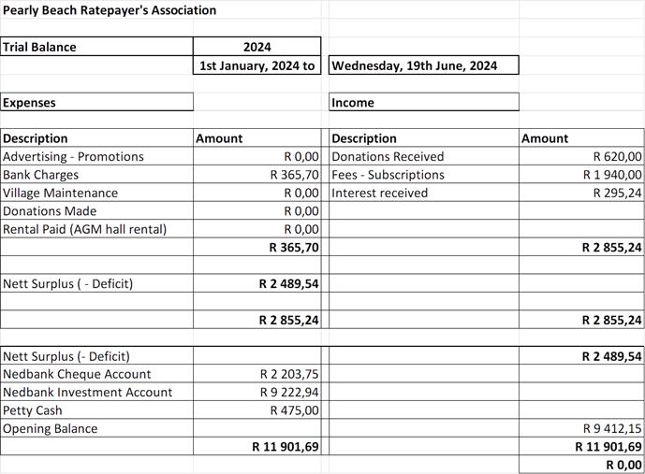
BUILDING PLANS: MAY 2024

Pearly Beach Resort

Erf 2497 34 Melkhout Street Addition

Pearly Beach Village

Erf 370 106 Broadway Street New House
Erf 90 8 The Crescent New House
Erf 319 63 Central Street Alteration
Erf 361 19 Arcadia Street Minor Works

GENERAL

Nelia advised the location of the “Beware of Tortoises” signs requested for the village.

Alderman Coetzee stated that the PB Conservancy had requested that the 4 street lights at the entrance to the village be turned off and that they had applied for “Dark Place” certification. This will be discussed at the next Ward Committee meeting.

The storm water retention dam in Arc Street has been enlarged to accommodate excessive rain.

A second camera will be bought for the Drop-off zone which will have a better resolution and a wider range.

With nothing further to discuss, the meeting was closed at 3.45pm. Our next meeting will take place on Friday, 30 August, at 2 pm at the Seeff Office.

____________________ ___________________ _____________
CHAIRPERSON SECRETARY DATE

