DRAFT MINUTES OF THE ANNUAL GENERAL MEETING OF THE PEARLY BEACH RATEPAYERS’ ASSOCIATION HELD AT 09H30 ON 22 MARCH, 2021, AT THE ANGLING CLUB, PEARLY BEACH
PRESENT : 23 members – their names are recorded in the Attendance Register attached to the original of this minute.

APOLOGIES : Messrs Pieter Reyneke, Vernon Potter,
Allen Schoeman
Mesdames Wilma Brent, Denise Nothnagel,
Elrina Versfeld
Rian & Mandie Smit; Guy & Anne-Marie Bury;
Raymond Ritchie & Emily Buchanan

WELCOME & DEVOTIONS
The Chairperson, Shirley Coetzee welcomed everyone and opened the meeting in prayer.

APPROVAL OF THE AGM MINUTES DATED 20 DECEMBER 2019

The minutes of the December 2019 AGM had been circulated to members via email and had also been posted on the PBRPA website and village notice board. Acceptance of the minutes was proposed by Jason Stonehewer and seconded by Daleen Stickling.

CHAIRMAN’S REPORT

The Chairperson presented her report for 2020. The full report is attached to the original of this minute and can be viewed on the PBRPA website at https://xplorio.com/gansbaai/pearly-beach-ratepayers

WARD COUNCILLOR’S REPORT

Alderman Coetzee presented his report which is attached to the original of this minute and can also be viewed on the PBRPA website at the following address: https://xplorio.com/gansbaai/pearly-beach-ratepayers
Various questions were raised from the floor and all these were addressed by the Ward Councillor - including the following:

The possibility of disconnecting from Eskom, the speed dip in Main Road, the allocation of dips instead of speed humps, the possible closure of the launch site at Blue Water Bay, the clearing of the hotel development site at Esplanade and the removal of the asbestos water pipes.

TREASURER’S REPORT

The Treasurer’s report was presented by the Treasurer, Trevor Archer. This report is included below. The Chairperson thanked the Treasurer for the presentation of his report.

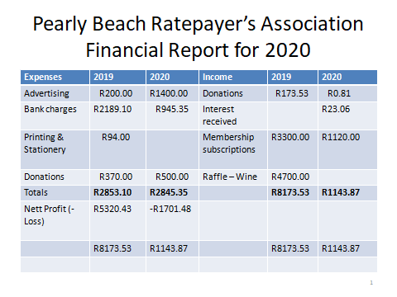

ELECTION OF MANAGEMENT COMMITTEE

The Chairperson called upon Alderman Coetzee to preside as the Electoral Officer for the election of the 2021 committee. After discussion, the meeting agreed to the re-election of the present committee and the current committee agreed to stand for another year.

Proposed by Daleen Stickling, seconded by Lindsay Halkett and unanimously approved by the meeting.

These members are Shirley Coetzee, Nelia Hurter, Vivienne Burton-Moore, Wilma Brent, Trevor Archer and Jason Stonehewer.

GENERAL

Nelia Muller offered a vote of thanks to Alderman Coetzee for his work and dedication to Pearly Beach as Ward Councillor over the last ten years.

David MacDonald suggested that all local businesses in our village should be invited to join the PBRPA.

It was noted that members should be encouraged to visit the PBRPA website on Xplorio for information about the village. Pearly Beach has approximately 400 permanent residents and residents can also join the PB Community group on Telegram. The Chairperson also stated that there is a PBRPA notifications whatsapp group which members can join to receive information about the village as well as municipal notifications affecting the supply of water and electricity.

There being no further business to discuss the Chairperson thanked everyone for their attendance and closed the meeting at 10h25.

_______________________ _______________ ____________
CHAIRPERSON SECRETARY DATE

